Document Prepared By-

**RAJANIKANT PANDA,** Coma Science Group, University of Liege, Belgium

Supervised By –

**Prof. Steven Laureys,** Coma Science Group, University of Liege, Belgium

**Dr. Jitka Annen,** Coma Science Group, University of Liege, Belgium

**Dr. Srivas Chennu,** University of Kent, UK

**EEG PREPROCESSING ROADMAP USING *MOHAWK***

Mohawk Pipeline have many part fully automated, some semi-automated and some are manual

Steps to do manual

1. Data Selection
2. ICA component labeling as good or bad for de-noising
3. To prepare the report

Steps have semi-automated

1. Bad channel detection
2. Bad signal epoch detection

Fully automated

1. Pre preprocessing for- > importing data, event cannel location; down-sampling, filtering and deleted bad channel interpolation
2. Post processing for power-spectral, connectivity, graph theory and result visualization

Note: text is written in purple for “automated” steps and in blue for “semi-automated or manual steps”

* **Step 1: Import Data – filtering – epoching**
* Save EEG data in one the following format: EGI raw file; MFF file; MFF folder
* Open Mohawk: In Matlab APP’s section, *click on Mohawk logo*
* ***Load EEG file from dedicated folder by selecting appropriate file format of the data. Give the name of for processed data “prefix”***

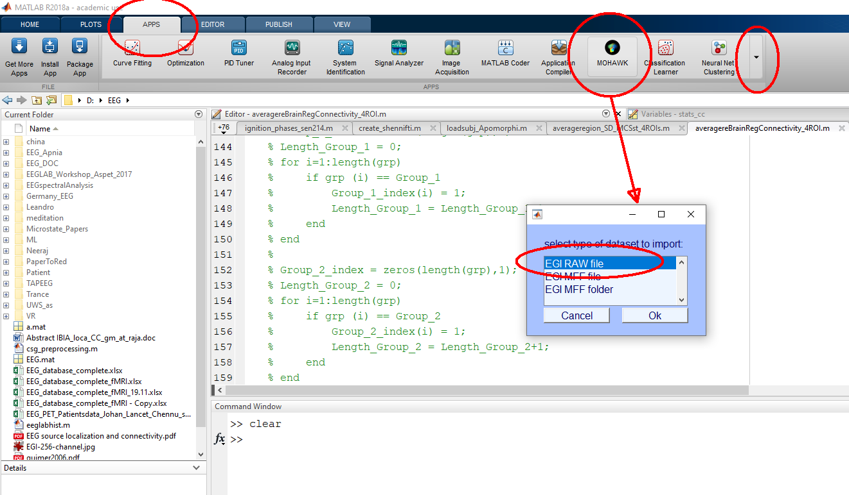

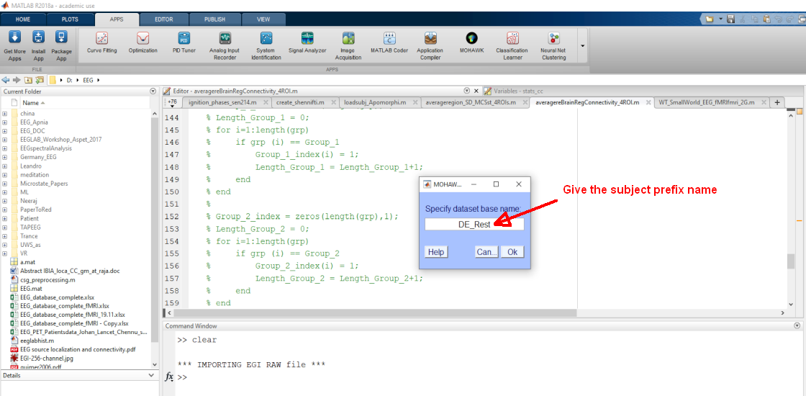

* ***Then the file will be automatically imported in EEGlab and fallowing preprocess will happen***
  + Imports: events; channel locations;
  + Downsampling to 250 Hz
  + Low-pass filtering below 45Hz
  + High-pass filtering above 0.5 Hz
  + Notch Filtering for power line interference (50Hz)
  + Epoching into 10 seconds Epochs
  + Removing baseline
* **Step 2: Removing noisy channels/signal epochs:**
* ***Set channel variance threshold*** (number)
  + Max. 20 channels selected for semi-automatic rejection

Note: a good channel variance threshold should remain below 500

* ***Set epoch variance threshold*** (number)
  + Try to keep minimum 60 epochs (that is 10min data) from whole signal
  + Note: a good signal epoch variance threshold should remain below 50

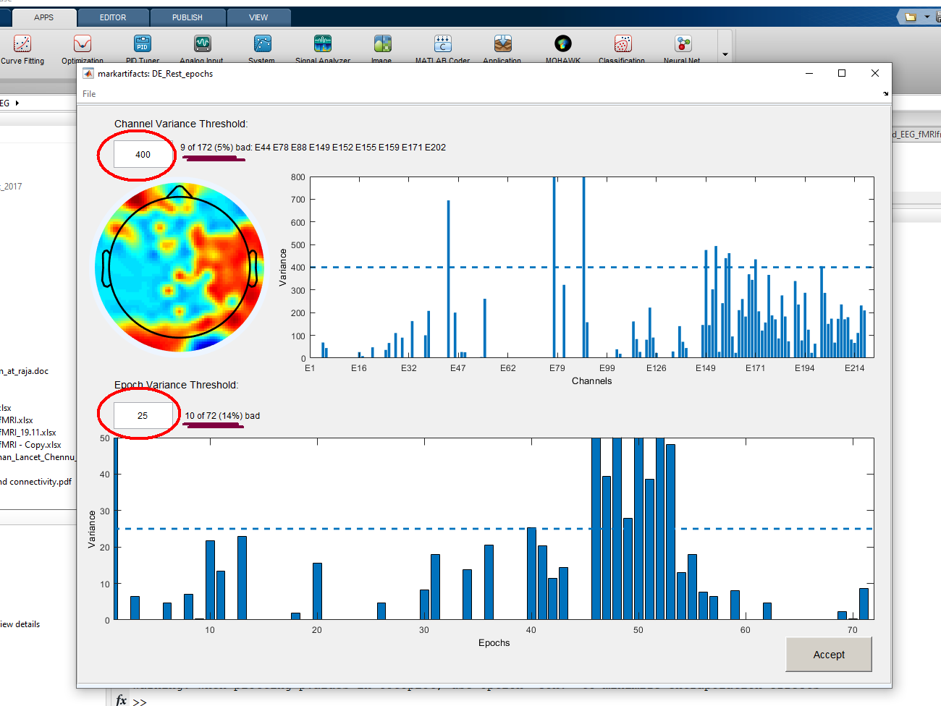

**Then the noise data/channel selection will be appear, where noisy/bad channels and epochs will be pre-selected**

For rejection (Preselected Channels => grey; Preselected Epochs = yellow)

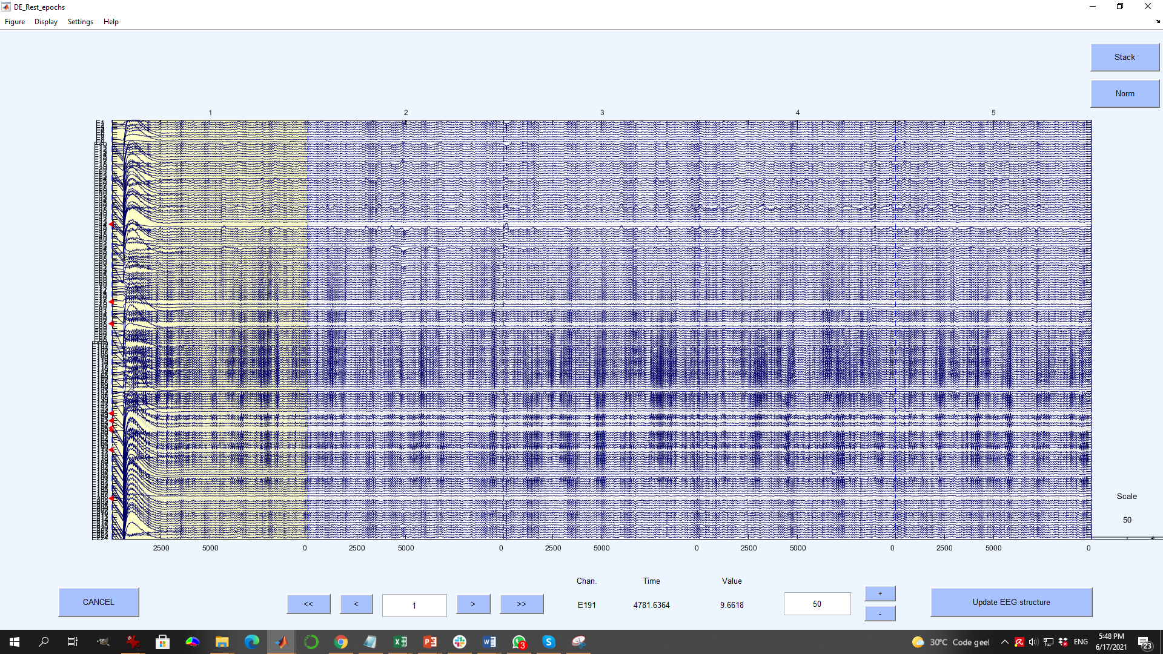

* **Visual inspection** to verify/modify the semi-automated selected channel/epoch.
  + Epoch selection: *mouse left click on epoch ->* select / deselect
  + Channel selection: *mouse right click* on *channel* 
    - *Check “toggle bad channel status”*
    - *Double check the channels selections*
    - *If done wrongly any channel, re “toggle” the channel*

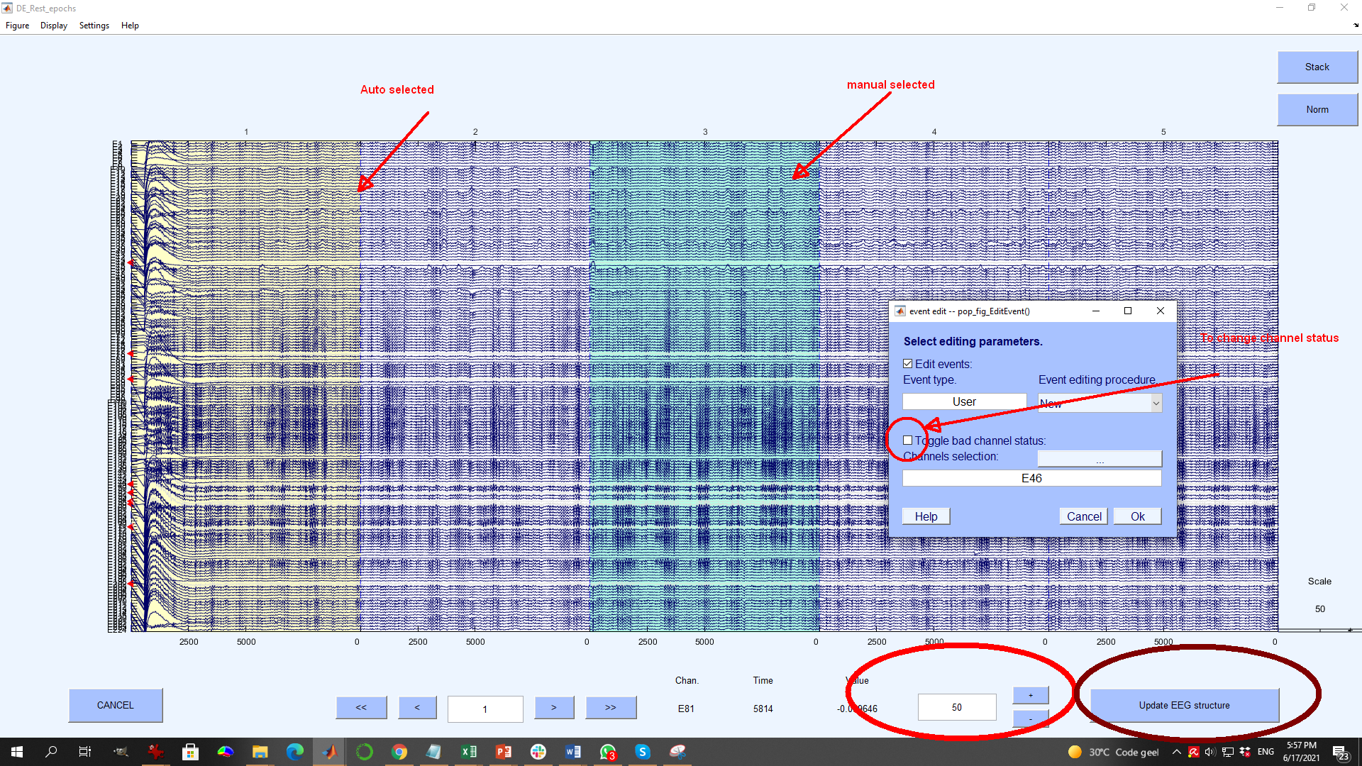

Note: For better visibility you can change:

* The number of channels to display: *settings > number of challenge to display (*90 is a good number)
* *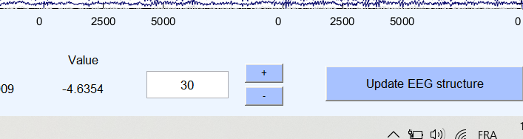*Amplitude: set number (50 is a good number)
* After noisy channels and epochs are marked for rejection:***update eeg structure***

**Then it will ask you to over-write the “\*\_wpoch.set”, press [Yes]. Then ICA will run noise component removal.**

* **Step 3: Removing artifactual components:**
* **Run ICA** (runica, will automatically launches after updating EEG structure)
  + Note: ICA can take 15-40 minutes to run (depending on the computer power and EEG data duration)
* After ICA has run verify each of the component one by one, using the two windows ; **manually mark art factual components for rejection**

*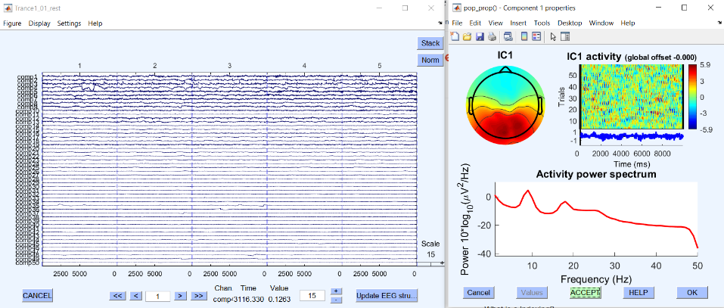*

Identify bad/noisy components looking in the following in the order (see below for more information on artifactual components):

1. **From ICA time series**
2. **From ICA spatial map**
   * **1st, Spatial view: scalp topography** (page 6)
     + Activity should:
       - Relatively large blops;
       - Change spatially in a relatively gradual progression
       - Location: ex, eye activity or muscular activity
   * **2nd, Activity power Spectrum** (page 7)
     + Usually exponentially decreasing until around 50 Hz with shoulders in certain frequency like alpha
     + Artifacts:
       - Decaying to abruptly or rising in high frequency (ex: Abrupt increase in the 45Hz – 50Hz)
     + Note: artifact can display similar power spectrum as relevant brain activity
   * **3rd, Temporal view of all the** components (left panel): 1 line = 1 component for the whole timeseries.

**ERP-image**, plots of collections of epochs overtime with color code for activity

* + - In recordings not involving task or stimuli, activity should be rather spread over time

**Bad IC component selection from ICA time series**

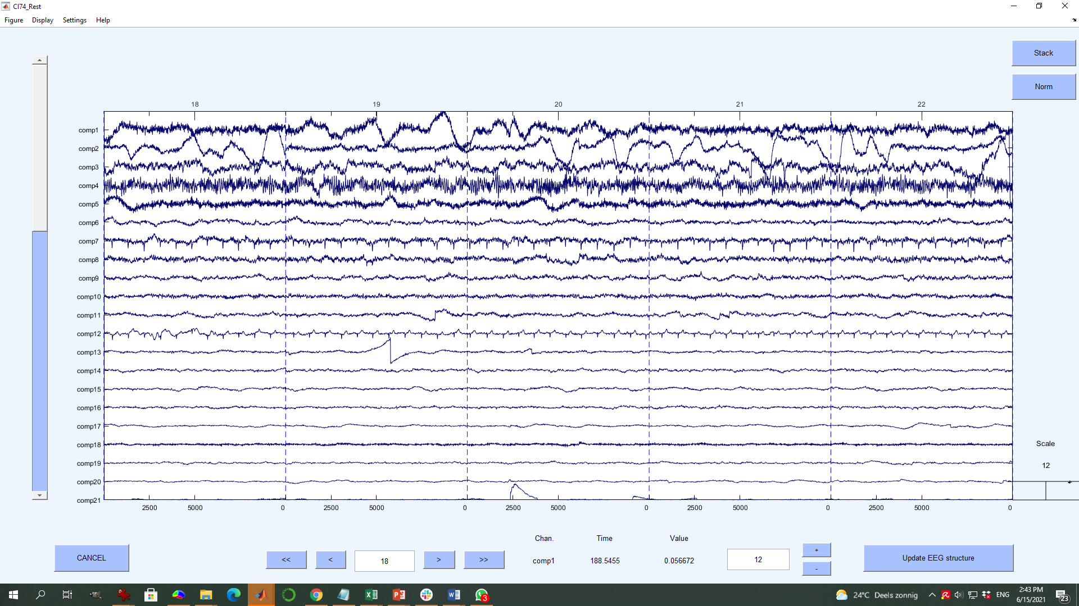

Bad ICA

Component

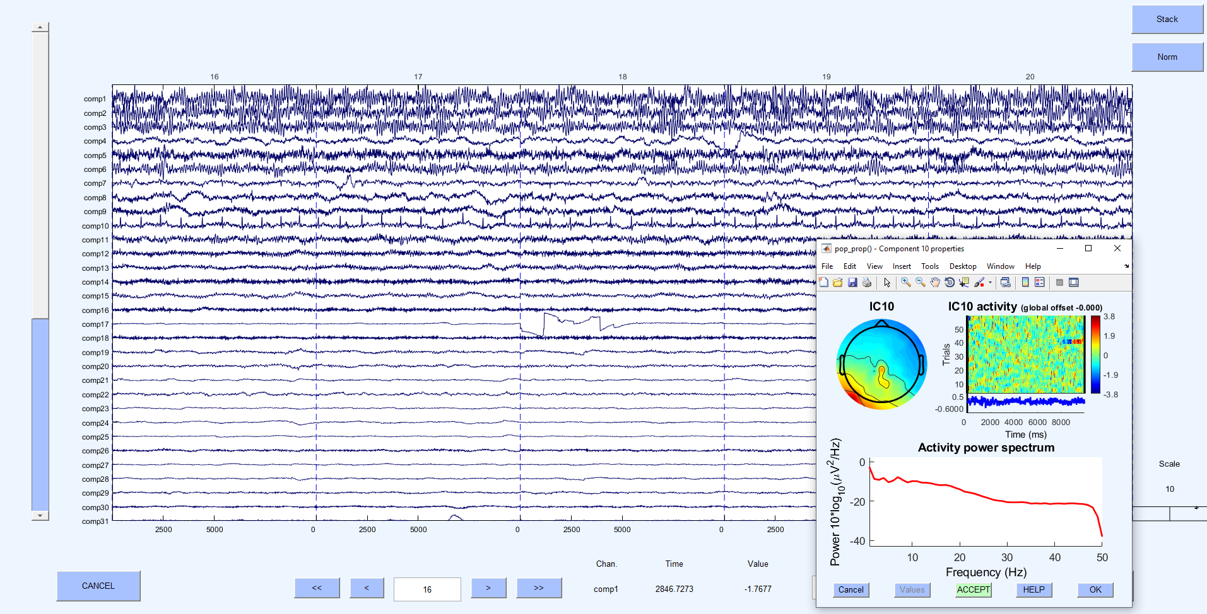

**Bad IC component selection from ICA Spectral**

**ICA**

**Activity Temporal**

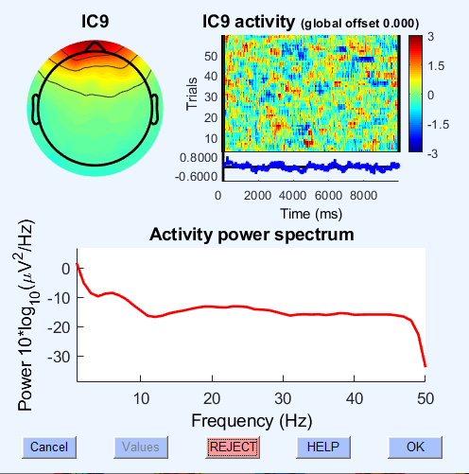

**ICA**

**Activity Power spectrum**

**ICA**

**Spatial map**

**Noisy ICA Spatial map**

 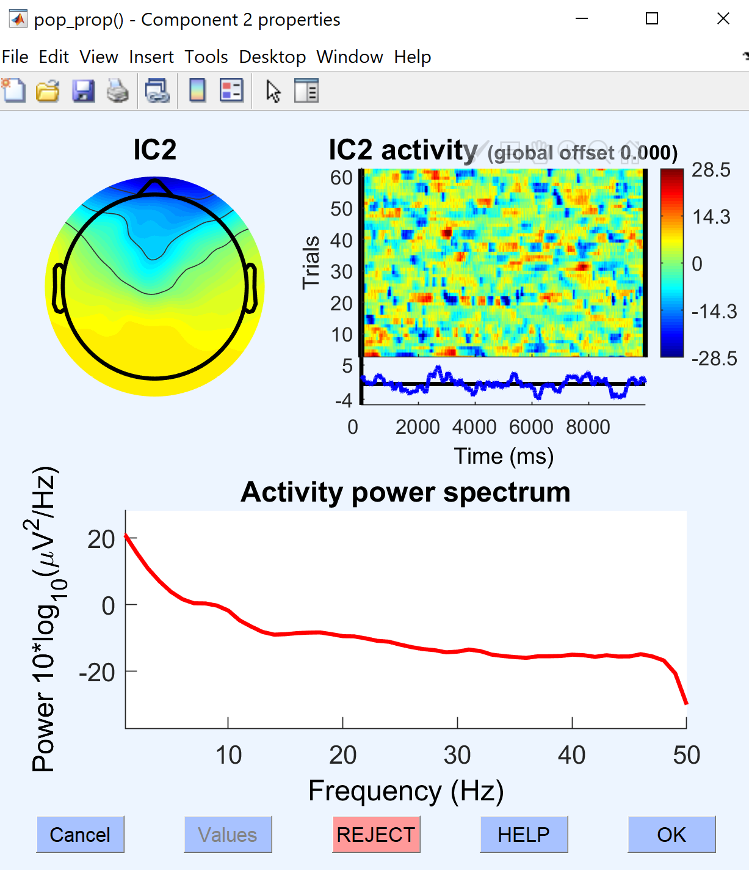

1. Ocular activity/Eye Blink Ocular activity/Eye Blink

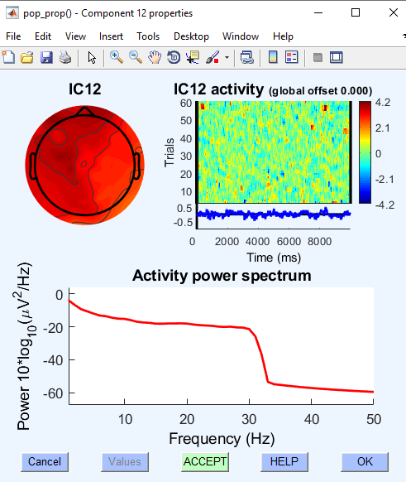 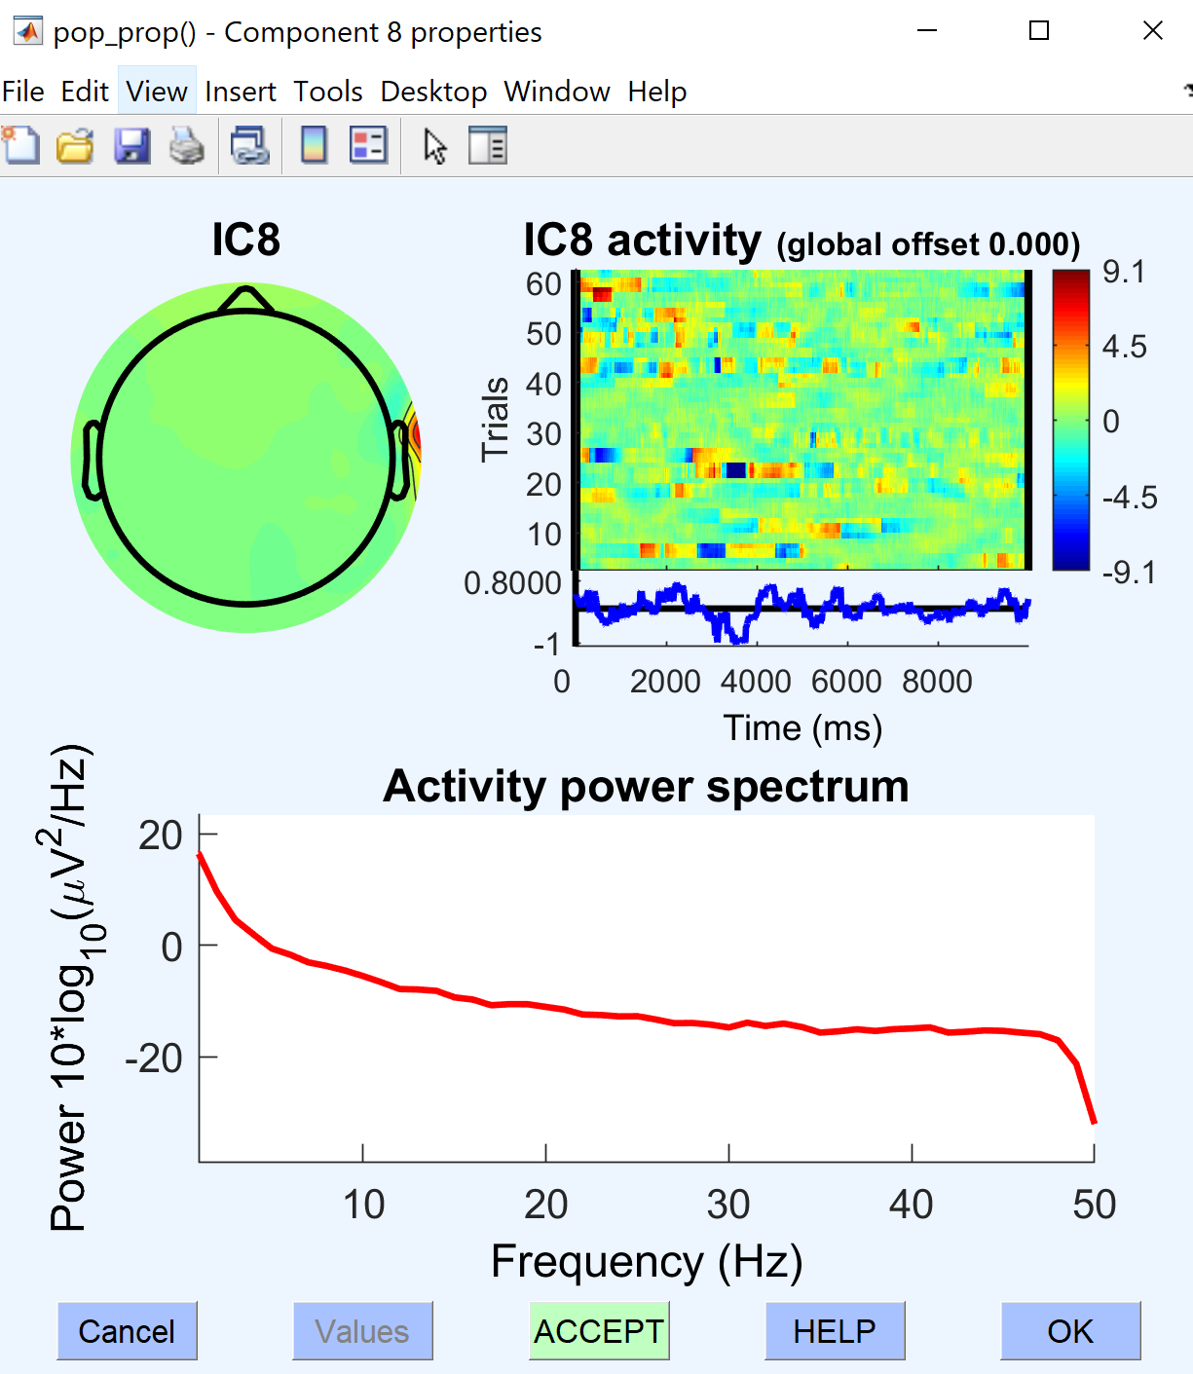

2. Muscle artifact Muscle artifact

**Noisy Activity Power spectrum**

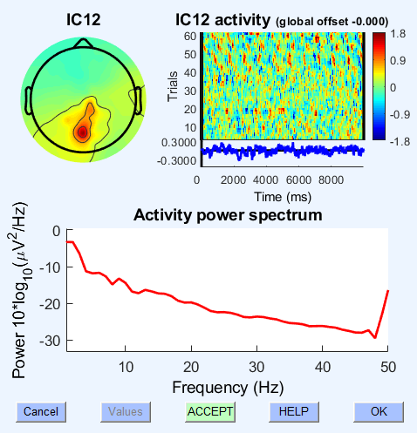 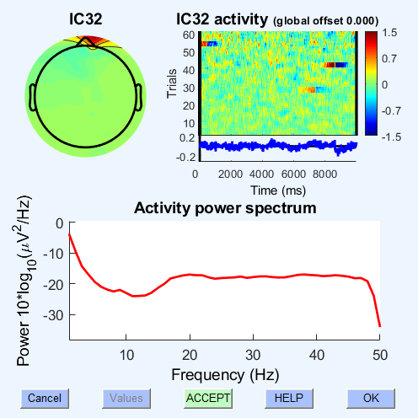

Bad Power spectral Bad Power spectral

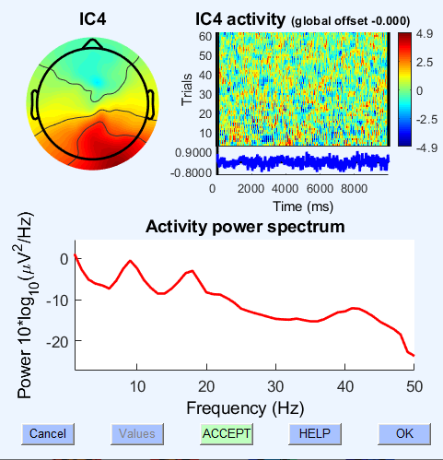 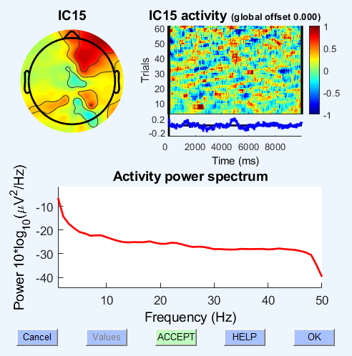

**Good Power spectral Good Power spectral**

**Noisy Activity Temporal**

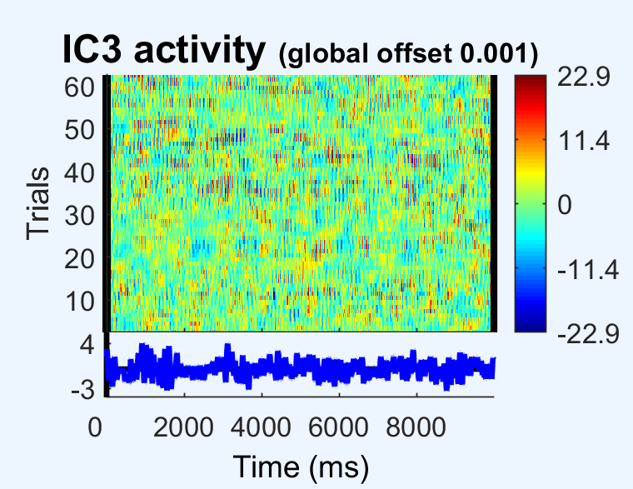 

**Good**

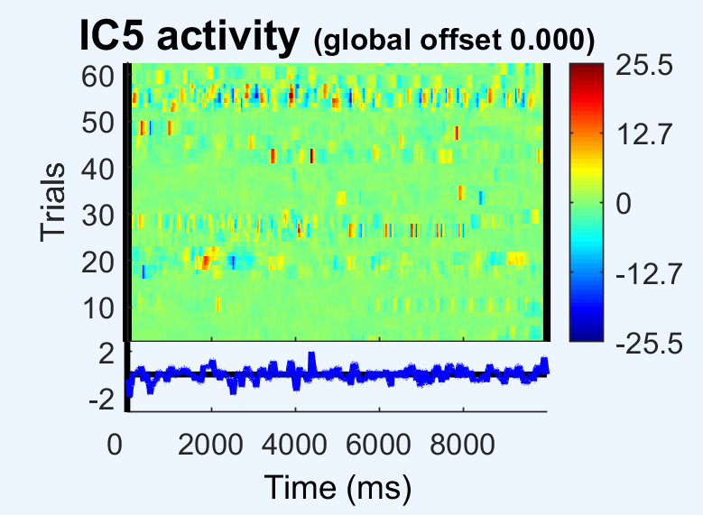

**Bad**

* **After marking artifactual components for rejection:** ***update EEG structure and Accept the further automated discarded channel and signal epochs.***

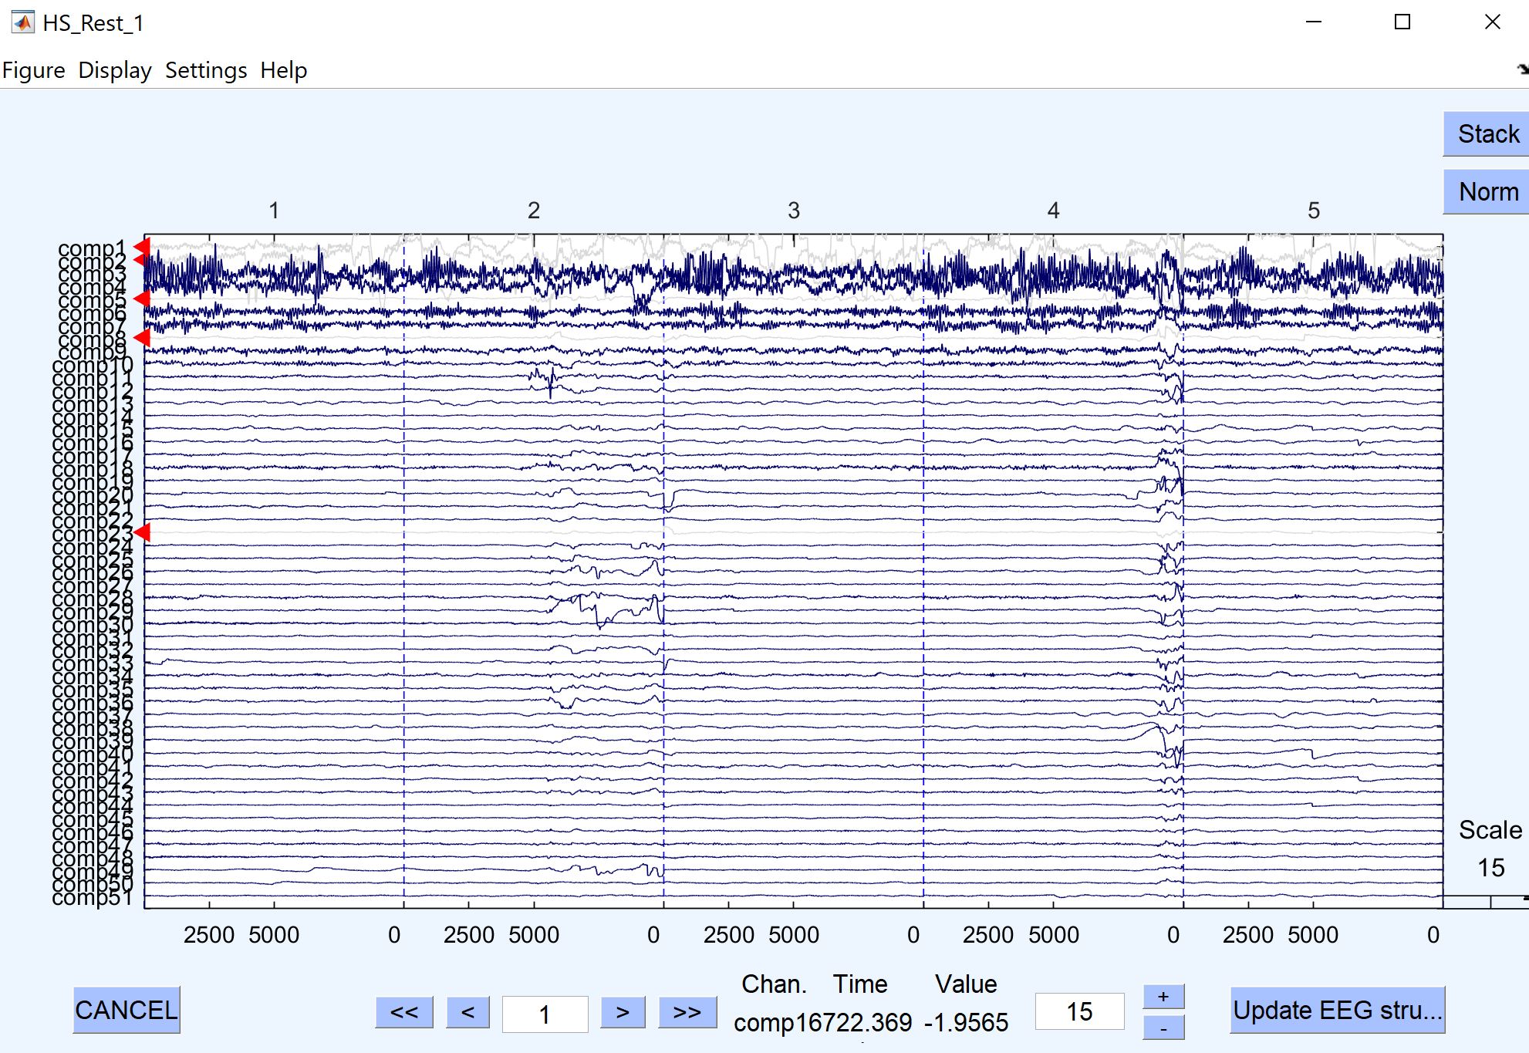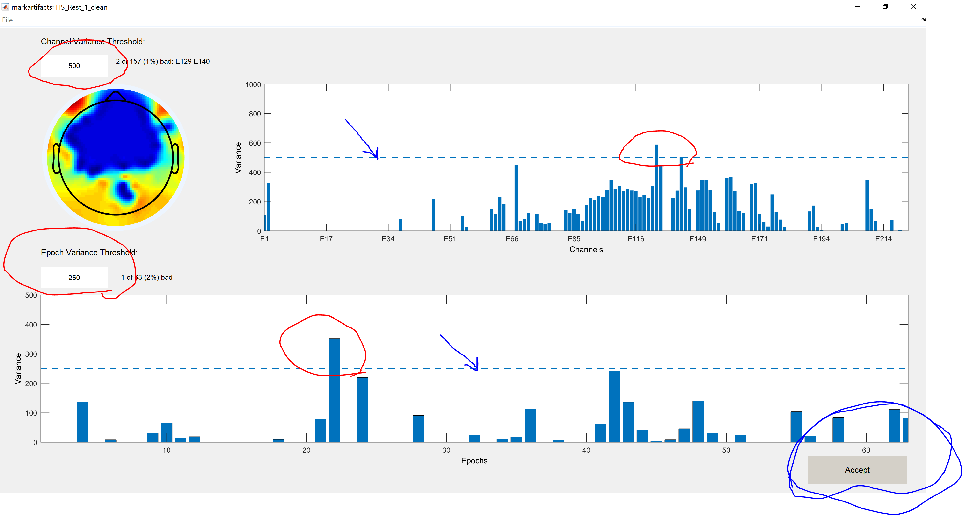

* **(Step 4, optional): Removing remaining noisy channels/epochs:**
* After ICA, mohawk gives you opportunity to remove noisy channels/epochs based on variance (no visual inspection at this stage).
* Similar method than “Step 2”.
* Take amount of data removed in the first place to avoid removing to much data.
* Interpolating bad channels (spherical interpolation)

**Post processing:** Calculating multitier power spectrum + connectivity + Visualization

**PHYSIOLOGICAL ARTIFACTS**

1. **Ocular activity:**

The eye can be electrically modeled as a magnetic dipole and it distorts the electric field in the region when it moves. This distortion is known as the EOG (Electrooculogram) signal and has an amplitude usually one order of magnitude larger than the EEG signal, reaching values around 100-200 microvolts.

**Types of effects:**Blinking, lateral movement, eye movements

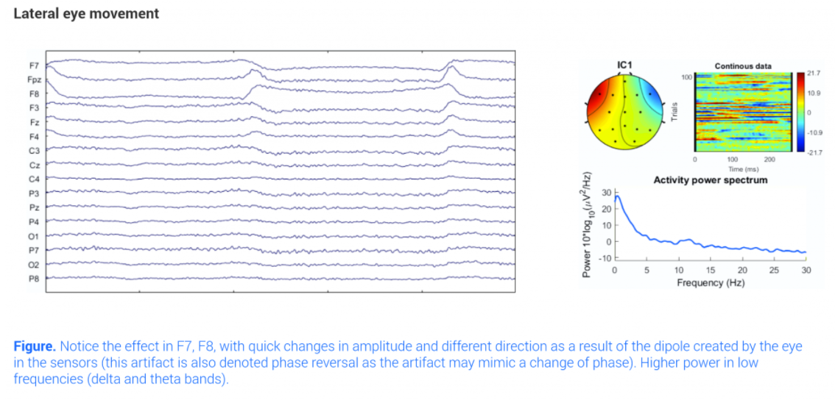**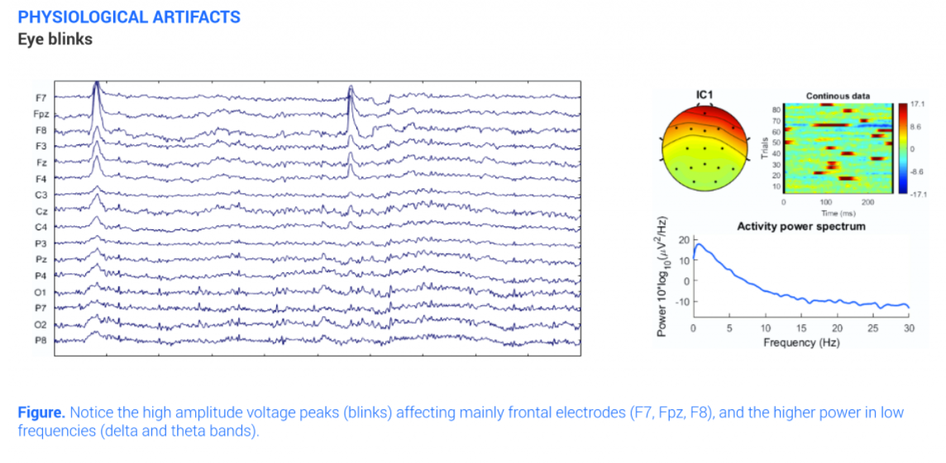Effect on time-domain:**Blinking produces a quick change with high amplitude on the EEG signals in the electrodes of the frontal area, more pronounced in those closer to the eyes. Lateral movements of the eye affect also the frontal areas but are more significant the closer to the temples. In general the artifact amplitude of the artifact is almost proportional to the angle of gaze.   
  
**Effect on frequency domain:** Effect in low frequencies that can be confused with delta and theta bands

1. **Muscle activity:**

Muscles produce electrical activity when they are contracted. This activity can be measured and the resulting signal is called electromyography (EMG). That electrical activity produced by the muscles can interfere with the actual EEG activity. We can observe these high frequency artifacts with the naked eye. (Clenching the jaw, neck and shoulder muscles tension, swallowing, chewing, talking, sucking, sniffing, grimacing, frowning or hiccupping)

**Effect on time domain:** We can observe a high frequency signal that overlaps the EEG signal. The amplitude correlates with the strength of the muscle contraction.

**Effect on frequency domain**: Effect in high frequencies overlapping artifacts in beta and gamma EEG bands

**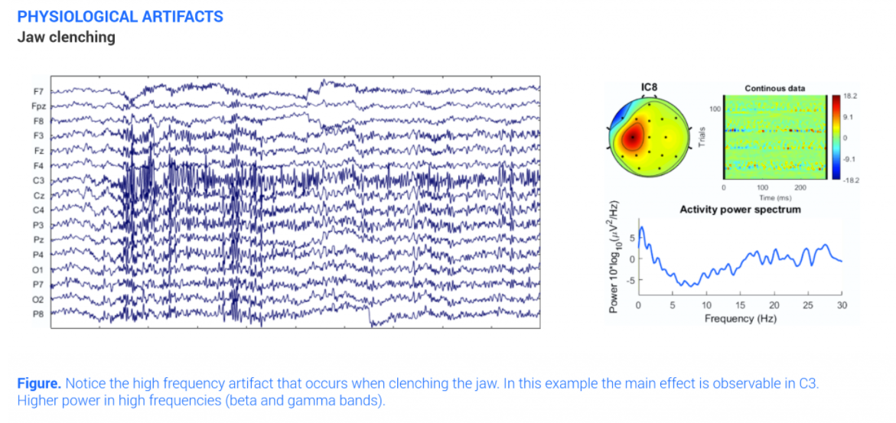**

1. **Cardiac activity:**

Electrical activity from the heart. This signal is called Electrocardiogram (ECG) but also referred as to pulse artifact. Although the amplitude of the ECG is low on the scalp, sometimes, depending on the placement of the electrode or the body shape of the participant we would see a rhythmic distortion on the EEG signals.

**Effect on time domain:** A rhythmic pattern, corresponding with the heartbeats that overlaps the EEG signal.

**Effect on frequency domain**: The frequency components of the ECG overlap EEG band frequencies so it is difficult to visualize them with the naked eye

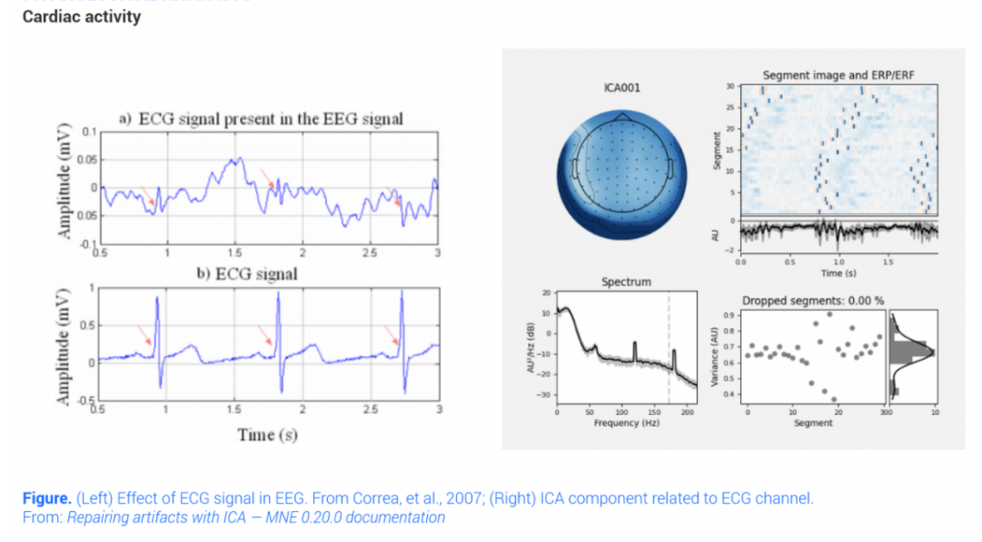

1. **Perspiration**

Sweat glands of the skin. Small drops of sweat produced by the glands cause changes in the electrical baseline of the electrodes. In case of intense perspiration it could even create shorts between electrodes.

**Effect on time domain**: Slow waves overlapping the EEG signal.  
**Effect on frequency domain:** Low frequency artifact that overlaps delta and theta bands principally

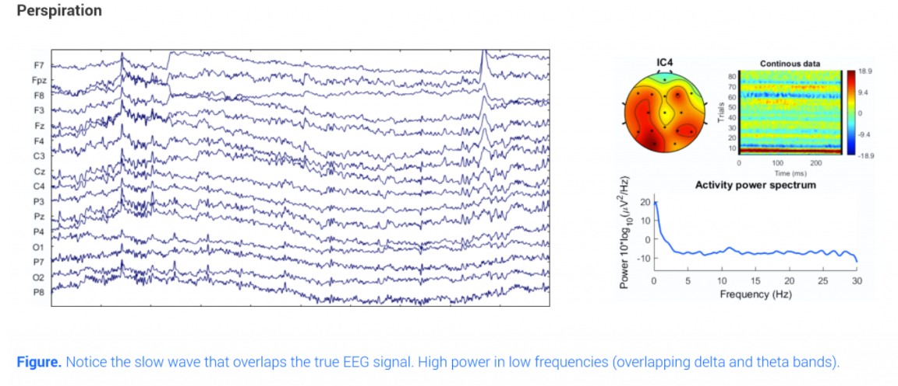

1. **Respiration**

Movement of chest and head when breathing (inhale / exhale). It is more common in sleep recordings as respiration-related movement modifies the contact between the electrodes and the scalp if the participant is lying on a bed.

**Effect on time domain**: Slow waves synchronized with breathing rhythm that overlaps the EEG signals.  
**Effect on frequency domain**: Low frequency artifact that overlaps delta and theta bands.

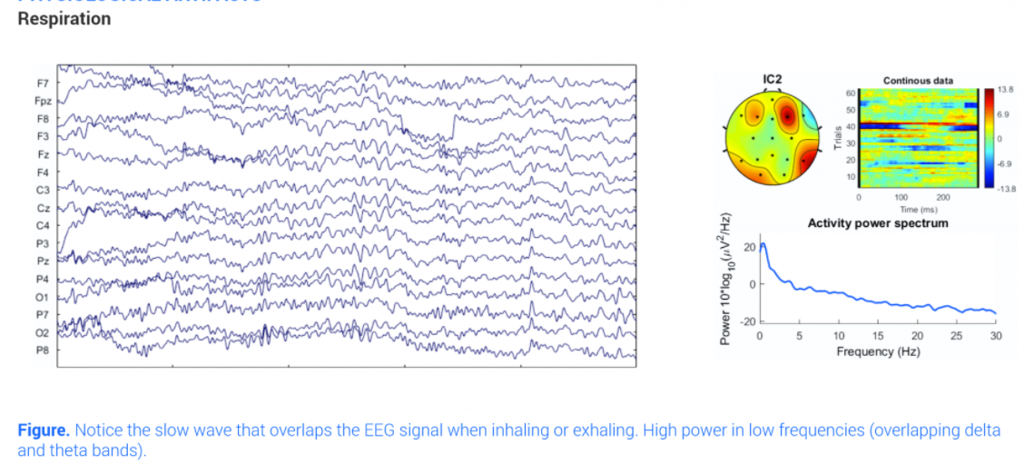

**NON-PHYSIOLOGICAL / TECHNICAL**

1. **Electrode pop:**

Temporary failures in the contact between the EEG sensor and the scalp produced by touching the sensor or by spontaneous changes in electrode-skin contact. It is due to changes in contact potential between the scalp and the electrode.

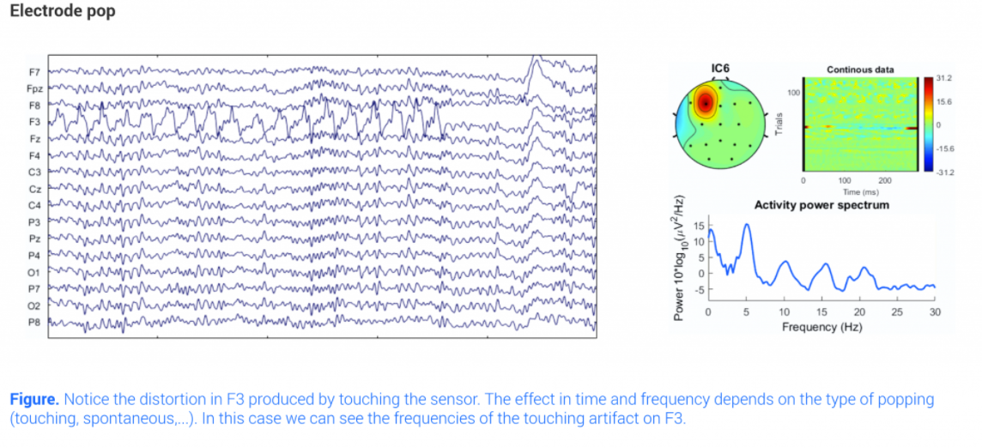**Effect on time domain:** Abrupt and usually high amplitude interference on the EEG signal usually localized in a single channel.   
**Effect on frequency domain**: The characterization of an electrode pop is difficult due to the wide range of possible distortions.

2. **Cable movement:**

Movement of the cables connecting the electrodes and the amplification system. Changes in the electromagnetic fields produce distortion in the signal recorded and also in the scalp-sensor contact.

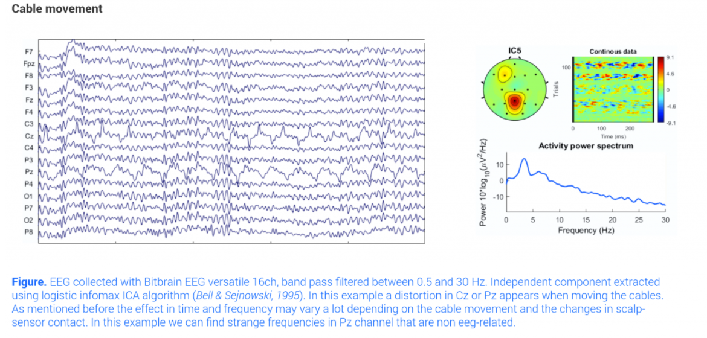**Effect on time domain**: It is very dependent on the type of cable movement. If the movement is rhythmic, distortions overlapping EEG signals will appear with the same rhythm that the cable movement.  
**Effect on frequency domain**: It also depends on the type of movement. If movements are rhythmic we can find non-EEG related frequency peaks

1. **Incorrect reference placement:**

Reference channel not placed or bad contact on the reference channel. The signal recorded is not EEG.

**Effect on time domain:** abrupt changes in all the channels with high amplitude. All channels will converge slowly (filtering effects) to actual EEG signals when the reference is placed properly.  
**Effect on frequency domain:** very high power in all channels, and in non-eeg related eeg signals.

**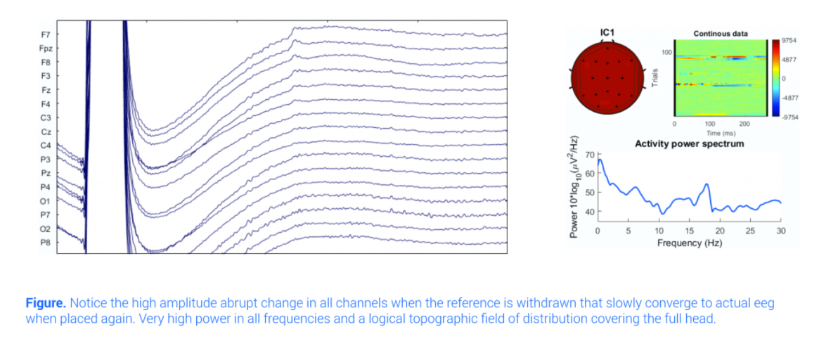**

1. **Body movements:**

Body movements, principally affected by head movements. When moving, although unintentionally, the contact between electrode and skin is affected and the EEG signal corrupted.

**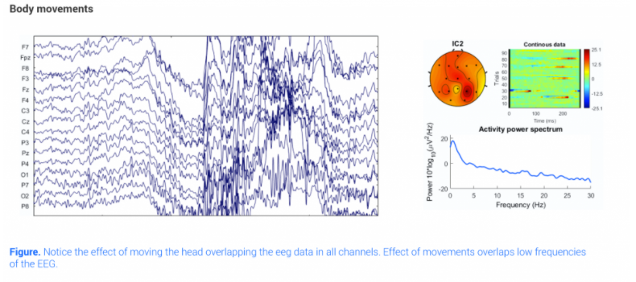Effect on time domain**: temporary slow waves corresponding with the rhythm of the movement.  
**Effect on frequency domain:** Effect is localized in lower frequencies overlapping delta and theta bands.

**Post processing:**

1. The **Power spectrum** calculated (automatically) using maultitaper method by “Fieldtrip” toolbox.

D:\EEG\Patient\figures\KeDe_up_spec.tif

1. **Connectivity:** Scalp level connectivity were calculated using dwPLI between each pair electrode channels using using “Fieldtrip” toolbox. The dwPLI (debiased weighted Phase Lag Index) demonstrate “phase synchronicity”. dwPLI between a pair of EEG channel time series is a number between 0 and 1 indexing the extent to which the phases of the oscillations in each channel within a particular band have a consistent phase relationship with respect to each other.

Higher the dwPLI value, higher the synchronicity between two channels and zero indicate no synchronization (self-connectivity).

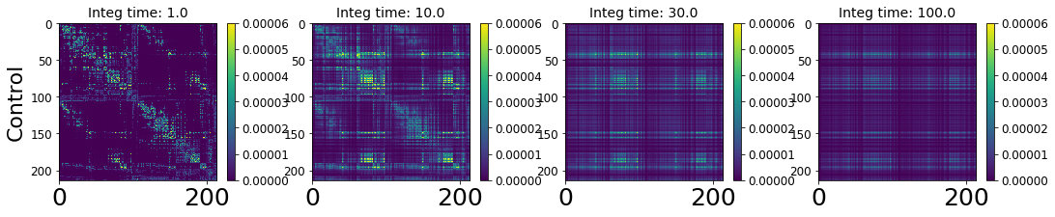

**Brain Region**

**Brain Region**

**Connectivity Matrix**

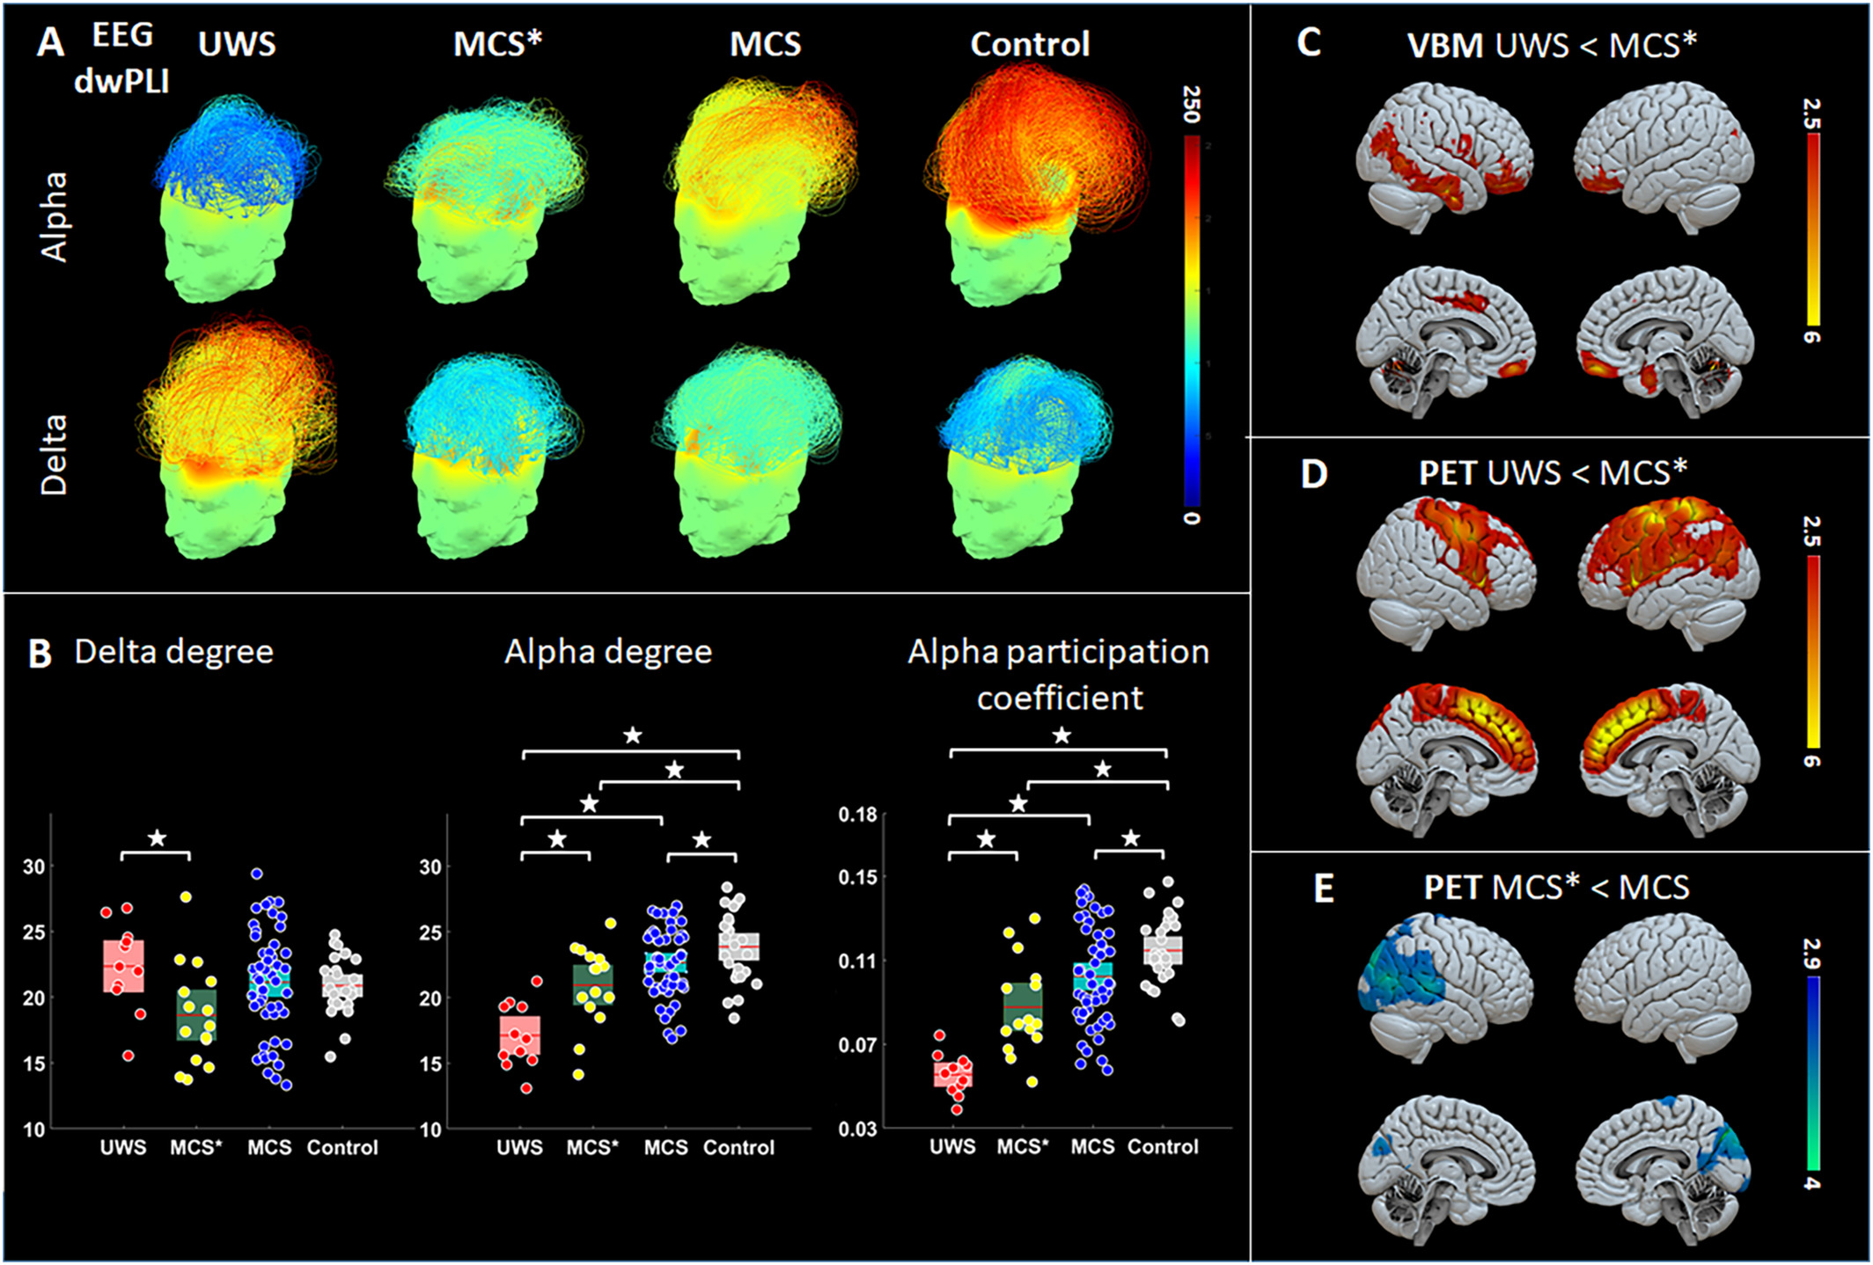

**Connectivity Matrix super imposed to head scalp.** Arc length and color represent brain connectivity. Color on Scalp represent no of connection each electrode have (degree)

1. **Graph Theory**

* **Degree :** Represent total number of connections are there for every node
* **Participation Coefficient:** Represent Brain Network Integration >> how well the functional module are well connected
* **Clustering Coefficient:** Represent Brain Network Integration >> how well the functional module separated

**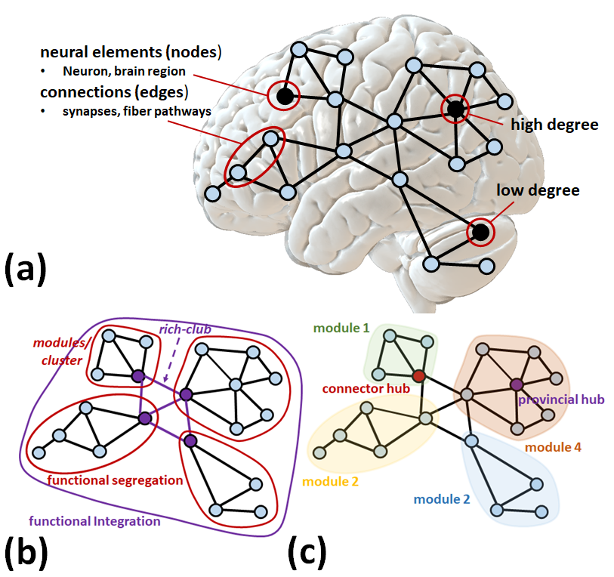**

****

Figure above representations brain network topological properties, which can be measured by graph theory approach. (a) Brain networks can be labelled and analyzed as graphs encompassing a group of nodes (neurons, brain regions, scalp electrode channels etc.) and a collection of edges (structural

Connections or functional relationships). A node relatively high number of edges/connections called high-degree often referred as hubs. (b) Functional segregation (i.e., clustering coefficient) designated by strong functional coupling within modules/clusters (red circular) and functional integration (i.e., participation coefficient) represent connection between functional modules/clusters (purple circular). (c) nodes have higher within or between module connectors are represented as hub. ‘Provincial hubs' are the node which have high degree and primarily connect to nodes in the same module/cluster. In other hand, ‘Connector hubs' nodes may not have high-degree but have diverse connectivity shape by connecting to several different modules/clusters within the network.



**Mohawk Clinical Report Sample:**

|  |
| --- |
| EEG à haute densité (voir annexe) |

Nous avons enregistré l’activité électrique du cerveau au repos au moyen de l’EEG à haute densité (256 électrodes). Nous avons mesuré les différentes bandes de fréquences (delta, theta, alpha et beta) et nous avons mesuré la connectivité corticale au moyen de la théorie des graphes chez le patient comparé à des sujets sains et d’autres patients.

Une réduction plus importante des mesures de connectivité des bandes alpha et des graphes a été observée chez le patient. Les modèles de connectivité de ce patient correspondent à ceux du groupe de patients avec un état d’éveil non répondant.

Chennu, et al. (2017) Brain networks predict metabolism, diagnosis and prognosis at the bedside in disorders of consciousness. Brain, 140(8), pp.2120-2132.

|  |
| --- |
| *Bande alpha des réseaux corticaux au repos chez les sujets sains et les patients en état d’éveil non répondant (ENR) et en état de conscience minimale (ECM)*      **ENR ECM Sujets sains** |
| *Figure 2: Réseaux corticaux chez ce patient, comparé aux sujets sains et à d’autres patients*  D:\EEG\Patient\figures\EP_SeAs_alpha_mohawk.tif D:\EEG\Patient\figures\EP_SeAs_participation coefficient_Alpha.tif |

**Patient ENR ECM Sains Patient**